By Sri Pranathi Challagolla

**Code Converters:**

* Code converters are combinational circuits that change data from one binary code to another.
* They are used for compatibility between systems, error reduction, and display purposes.
* Common types: Binary–Gray, Gray–Binary, Binary–BCD, BCD–Binary, BCD–Excess-3,

Excess-3–BCD.

**1.Binary to Gray code conversion:**

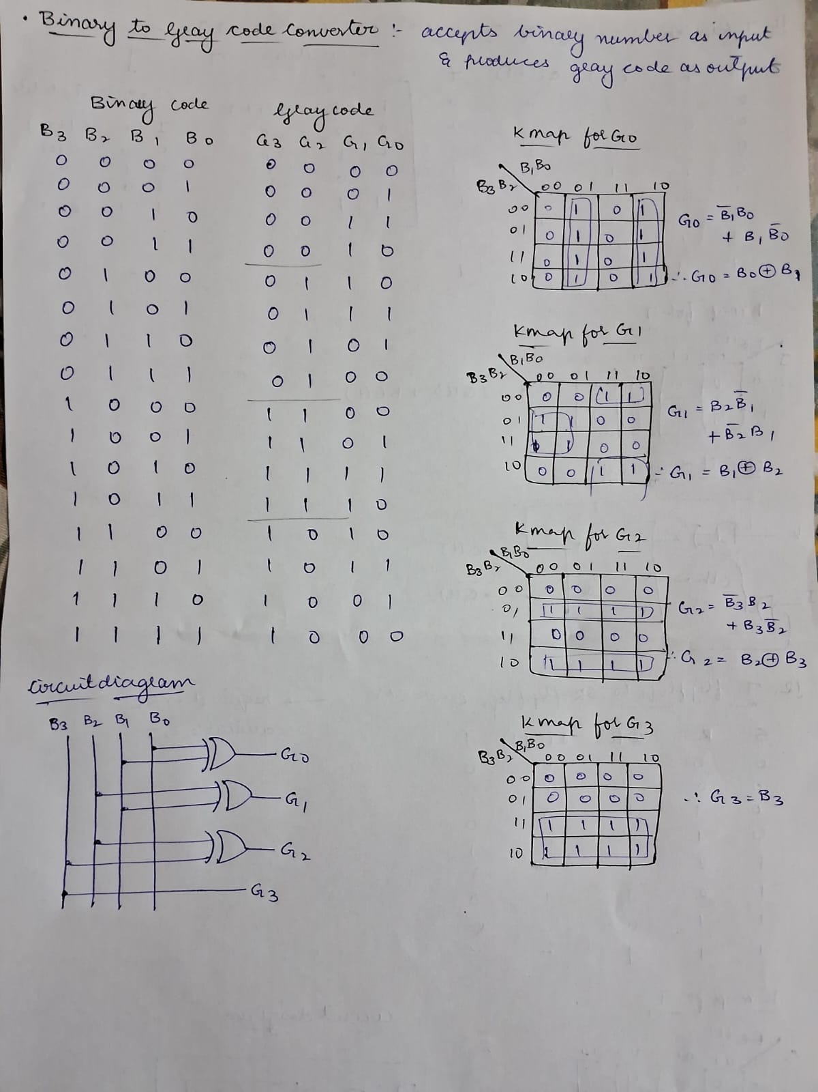

**Implemented Binary to Gray code converter:**

**Design:**

**Testbench:**

**2.Gray to Binary code conversion:**

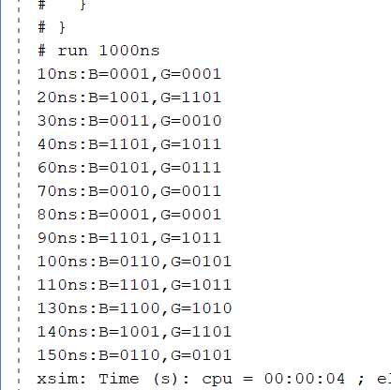

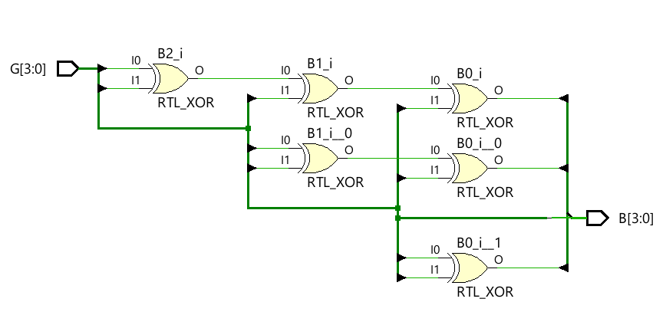

**Implemented Gray to Binary code converter:**

**Design:**

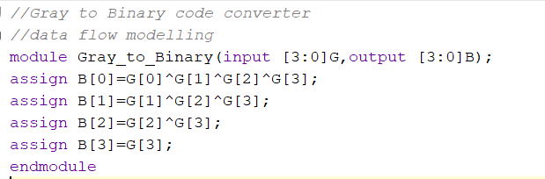

**Testbench:**

